Lab 1 – Practice

Replicating Sites

Part 1

Create the following site using boostrap <http://mode87.com/untame/demo/parallax/>



Part 2

Replicate the following page

<http://www.revillweb.com/demos/bootstrap3tutorial/>

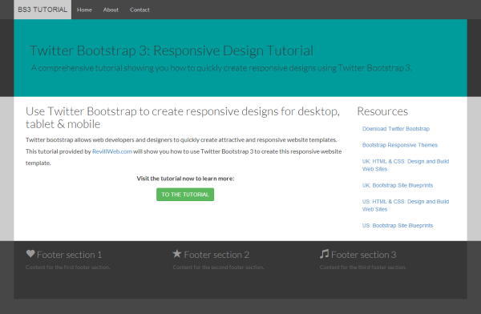

Task 3)

Replicate the following bootstrap site.

<http://codepen.io/jakestuts/full/eyvrx>